**ONLINE INTERNATIONAL SCHOLARSHIP PORTAL**

# TITLE PAGE

**BY**

**EZRA JOHN**

**(ST/CS/ND/23/135)**

**AUWAL AMINU MUHAMMED**

**(ST/CS/ND/23/181)**

**DEPARTMENT OF COMPUTER SCIENCE,**

**SCHOOL OF SCIENCE AND TECHNOLOGY,**

**FEDERAL POLYTECHNIC, MUBI, ADAMAWA STATE.**

**IN PARTIAL FULFILLMENT OF THE REQUIREMENT FOR THE AWARD OF NATIONAL DIPLOMA (ND) IN COMPUTER SCIENCE.**

**JULY, 2025**

# DECLARATION

We hereby declare that the work in this project titled “**Online International Scholarship Portal**” was performed by us under the supervision of Mal. Muhammad Zaharaddeen Bello. The information derived from literature has been duly acknowledged in the text and a list of references provided. The work embodied in this project is original and has not been submitted in part or in full for any other diploma or certificate of this or any other institution.

Ezra John ________________ _______________

(ST/CS/ND/23/135) Signature Date

Auwal Aminu Muhammed ________________ _______________

(ST/CS/ND/23/181) Signature Date

# CERTIFICATION

This project titled “**Online International Scholarship Portal**” meets the regulations governing the award of National Diploma (ND) in Computer Science, Federal Polytechnic Mubi, Adamawa State.

Mal. Muhammad Zaharaddeen Bello __________________

(Project Supervisor) Sign/Date

Mal. Mustapha Kassim __________________

(Head of Department) Sign/Date

Dr. Abdulrahman Saidu _________________

(External Examiner) Sign/Date

# DEDICATION

This project is dedicated to our beloved parents and love ones for their advice, encouragement and financial support towards our academic pursuit.

# ACKNOWLEDGEMENTS

We want to acknowledge Almighty God for His infinite mercy and protection throughout our academic activities and for granting us understanding in achieving our academic success.

We also recognize our supervisor Mal. Muhammad Zaharaddeen Bello, who took time, despite his busy schedule, to direct and guide us throughout this research work.

We acknowledge the Head of the Computer Science Department, Mal. Mustapha Kassim, for his moral encouragement throughout our period of study. We also acknowledge all the staff of the Computer Science Department for their support, encouragement, and the knowledge they have imparted to us throughout our studies.

We appreciate our lovely parents for their love and care and for giving us the opportunity to be trained and achieve our dreams.

Finally, we appreciate the efforts of our uncles and aunties for their encouragement and support throughout the course of our study, as well as our friends, relatives, course mates, and all well-wishers. We love you all. May Almighty God bless you abundantly. Amen.

# TABLE OF CONTENTS

TITLE PAGE i

DECLARATION ii

CERTIFICATION iii

DEDICATION iv

ACKNOWLEDGEMENTS v

TABLE OF CONTENTS vi

LIST OF FIGURES viii

LIST OF TABLES ix

ABSTRACT x

CHAPTER ONE 1

INTRODUCTION 1

1.1 Background to the Study 1

1.3 Aim and Objectives 2

1.4 Significance of the Study 2

1.5 Scope of the Study 3

1.6 Definition of some Operational Terms 3

CHAPTER TWO 5

LITERATURE REVIEW 5

2.1 Introduction 5

2.2 Related Work 5

2.3 Research Gap 7

2.4 Concept of Scholarship Portals 8

2.5 Importance of a Centralized Online System 9

2.6 Existing Scholarship Portals and Their Limitations 10

2.7 Technology in Web-Based Application Development 10

2.8 Database Management System 12

2.9 Summary of the Literature Review 13

CHAPTER THREE SYSTEM DESIGN AND ANALYSIS 14

3.1 Introduction 14

3.2 Disadvantages of the Existing System 14

3.3 Advantages of the Proposed System 14

3.4 Software Development Model 15

3.5 Method of Data Collection 16

3.6 System Design 16

3.6.1 Algorithm Diagram 17

3.6.3 Database Tables/Queries Structures 18

3.6.4 Database Entity Relationship Diagram 20

3.6.6 Input and Output Design 20

3.7 System Requirement Specification 23

3.7.1 Hardware Requirements 23

3.7.2 Software Requirements 23

3.7.3 Personnel Requirement 23

CHAPTER FOUR 24

RESULTS AND DISCUSSION 24

4.1 Introduction 24

4.2 Results 24

4.2.5 Available Scholarship interface 26

4.3 Discussion 27

4.4 User manual 28

4.4.1 System Installation 28

4.4.2 System Operational Guide 28

CHAPTER FIVE 29

SUMMARY, CONCLUSION AND RECOMMENDATIONS 29

5.1 Summary 29

5.2 Conclusion 29

5.3 Recommendations 29

REFERENCES 31

APPENDIX A 33

APPENDIX B 36

# LIST OF FIGURES

Figure 3.1: Waterfall model - - - - - - - - 16

Figure 3.2: Use case diagram- - - - - - - - 17

Figure 3.3: System Architecture - - - - - - - - 17

Figure 3.4: Entity Relationship Modelling - - - - - - 20

Figure 3.5: Database Entity Relationship Diagram - - - - - 20

Figure 3.6: Registration Form - - - - - - - - 20

Figure 3.7: Login Form - - - - - - - - 21

Figure 3.8: Student Registration form - - - - - - 22

Figure 3.9: Available Scholarships - - - - - - - 22

Figure 3.10: Accepted Students - - - - - - - 24

Figure 4.1: Registration interface - - - - - - - 25

Figure 4.2: Login Interface - - - - - - - - 25

Figure 4.4: Email Verification interface - - - - - - 26

Figure 4.5: Available Scholarship interface - - - - - - 26

Figure 4.6: Complete Profile Interface - - - - - - 27

Figure 4.7: Scholarship Status Interface - - - - - - 27

# LIST OF TABLES

Table 1: Admin Table - - - - - - - - - 18

Table 2: Student Table - - - - - - - - 18

Table 3: Provider Table - - - - - - - - 19

Table 4: Scholarships Table - - - - - - - - 19

Table 5: Application Table - - - - - - - - 19

# ****ABSTRACT****

*The Online International Scholarship Portal was developed to provide a centralized, secure, and user-friendly platform for managing international scholarship applications. The system was designed using PHP for server-side scripting, MySQL as the backend database management system, HTML and CSS for the structure and styling, and JavaScript for enhanced interactivity and real-time validations. The portal addresses challenges associated with the traditional manual scholarship application process, such as lack of accessibility, delays, and limited transparency. It features essential modules including Registration, Login, Email Verification, Available Scholarships, Complete Profile, and Scholarship Status. These modules collectively enable applicants to register securely, verify their accounts, explore suitable opportunities, complete detailed profiles, and monitor application progress in real time. The system ensures data security, improves accessibility, and streamlines scholarship management for both applicants and administrators. By providing transparent application tracking and secure authentication, it enhances trust and efficiency in the scholarship award process. The successful implementation of this project demonstrates that a web-based solution can significantly improve the speed, reliability, and fairness of scholarship management.*

# CHAPTER ONE

# INTRODUCTION

## 1.1 Background to the Study

In the age of globalization and digital transformation, access to international education has become more attainable yet increasingly competitive. Scholarships offered by governments, universities, non-governmental organizations (NGOs), and private institutions provide critical financial support for students seeking quality education abroad. These scholarships not only promote academic excellence but also encourage cultural exchange, diversity, and global development (UNESCO, 2022).

A **scholarship** is a financial award granted to students to support their education, often based on academic merit, financial need, leadership potential, or other specific criteria set by the sponsoring organization (Adekunle & Mohammed, 2021). Scholarships can be full or partial, covering tuition fees, accommodation, travel, and other living expenses, thereby removing significant financial barriers to education. Despite the growing number of scholarship opportunities globally, many students particularly those from developing nations face challenges accessing reliable and comprehensive information about available international scholarships (Adekunle & Mohammed, 2021). Most existing platforms are either fragmented, outdated, or limited in scope, often requiring students to navigate multiple websites, social media groups, or informal networks to find and apply for funding. This decentralized approach results in missed deadlines, fraud vulnerability, and low application success rates (Cheng, 2023).

An online international scholarship portal serves as a centralized digital hub where verified scholarships can be published, discovered, and applied for by users from any location. Such a platform will leverage web technologies to enhance accessibility, transparency, and efficiency in the scholarship search and application process. It will include features like advanced search filters, real-time notifications, deadline reminders, application tracking, and document submission all in one integrated system (Afolayan & Liu, 2022).

Moreover, digitizing scholarship access aligns with the United Nations Sustainable Development Goal 4 (SDG 4), which emphasizes inclusive and equitable quality education and promotes lifelong learning opportunities for all (UN, 2023). As more educational institutions and funding bodies adopt online platforms for outreach, a robust and user-centered scholarship portal can bridge the information gap, especially for underprivileged and remote students (Yeboah & Smith, 2021). Therefore, the development of an online international scholarship portal is both timely and necessary. It supports students in making informed decisions while improving the visibility and effectiveness of scholarship programs worldwide.

**1.2 Problem Statement**

In today’s digital world, where information should be readily accessible, students continue to face considerable challenges in locating and applying for international scholarships. One of the major issues is the absence of a centralized, credible, and up-to-date platform that aggregates global scholarship opportunities in a structured and user-friendly manner. Existing sources are often scattered across various websites, blogs, and social media platforms, many of which lack proper verification and consistency. As a result, students especially those from under-resourced or rural communities spend excessive time searching for legitimate opportunities, often encountering outdated information or fraudulent schemes. Additionally, there is limited guidance on eligibility criteria, required documentation, and application procedures, which further discourages prospective applicants or leads to disqualification due to incomplete submissions.

**1.3 Aim and Objectives**

The aim of this project is to design and implement an online international scholarship portal. Specific objectives include:

1. To develop a user-friendly web-based interface for searching and applying for scholarships.
2. To implement filtering options based on country, academic level, discipline, and eligibility.
3. To allow applicants to upload necessary documents and track application status.

**1.4 Significance of the Study**

This project holds immense significance for students, particularly those from developing and underrepresented regions. By providing timely and verified access to international scholarship opportunities, the proposed portal will empower students to explore educational options they may not have otherwise discovered. It eliminates the confusion caused by unstructured and scattered information across the internet, allowing users to make informed decisions based on eligibility, area of study, location, and funding coverage. With features such as automated notifications, application tracking, and personalized search filters, the platform aims to enhance students’ chances of successfully securing scholarships.

In addition, educational consultants, NGOs, governments, and policymakers will find value in the platform’s data aggregation and reporting capabilities. Consultants and NGOs can use the portal as a tool to guide students through the scholarship application journey, while government bodies and educational policymakers can access analytics from the portal to evaluate trends, gaps, and progress in educational outreach. Ultimately, this project will contribute to reducing fraudulent scholarship schemes, promote educational equity, and streamline the global scholarship application experience for all stakeholders involved.

**1.5 Scope of the Study**

This project is focused on the design and implementation of a web-based application that facilitates the management and accessibility of international scholarship opportunities. The system will include key functionalities such as user registration and login for both applicants and administrators, a dynamic search engine to filter scholarships based on parameters like country, academic level, field of study, and funding type, as well as an intuitive interface for administrators to upload and manage scholarship listings. Applicants will also be able to submit applications online, including uploading necessary documents and tracking the status of their submissions. To enhance user experience and engagement, the system will include automated notifications to alert users of approaching deadlines, newly added opportunities, and updates relevant to their interests.

While the initial version of the platform will cover the core features required to support a complete scholarship application cycle, certain advanced functionalities will be excluded in this phase. These include real-time document verification with third-party entities such as embassies or universities, online interviews, and payment gateway integration for application fees (if applicable). However, the system architecture will be designed with scalability in mind, allowing for future upgrades and the integration of these advanced features as the platform evolves.

**1.6 Definition of some Operational Terms**

**Database:** A structured collection of data stored electronically, designed for easy access, retrieval, management, and updating of information, such as user profiles and scholarship records (Elmasri & Navathe, 2021).

**Interface:** The point of interaction between the user and the software, typically designed to be user-friendly to enable seamless navigation and task execution (Shneiderman *et al.,* 2018).

**Portal:** A web application that serves as a centralized gateway for users to access information, services, or tools from multiple sources in one location (Cheng, 2023).

**Scholarship:** Financial aid awarded to students to support their education, often based on merit, financial need, or other specific qualifications (Adekunle & Mohammed, 2021).

**System:** An organized set of interrelated components working together for a specific purpose in this case, to facilitate the dissemination and management of scholarship information through a software solution (Pressman & Maxim, 2020).

**User Authentication:** A security process that verifies the identity of a user attempting to access a system, typically through login credentials such as a username and password (Stallings, 2021).

**Web-Based Application:** A software system that is accessed through a web browser over a network such as the Internet or an intranet (Afolayan & Liu, 2022).

# CHAPTER TWO

# LITERATURE REVIEW

### ****2.1 Introduction****

This chapter reviews relevant literature on the development and implementation of online scholarship systems, highlighting theoretical foundations, technological approaches, existing systems, their limitations, and how this project proposes to address the identified gaps. The review draws upon recent research studies, academic journals, and authoritative sources on web-based application development, scholarship management, and digital equity in education.

### ****2.2 Related Work****

Adepoju and Adebayo (2021) evaluated the role of digital scholarship portals in enhancing accessibility for students in Sub-Saharan Africa. Using a survey of 250 undergraduates, the study revealed that while 78% of users acknowledged improved access to scholarship information, 54% encountered usability challenges. The authors concluded that portal effectiveness depends not only on availability but also on user-centric design.

Chukwu and Uche (2022) developed and tested a web-based scholarship management system for a Nigerian tertiary institution. Through UML modeling and pilot implementation, 85% of users rated the system as more efficient than manual processes. The study recommended full institutional adoption to promote transparency and administrative efficiency.

Kumar and Singh (2019) conducted a comparative analysis of ten global scholarship portals. Their review found that most platforms lacked localized features and failed to offer comprehensive application support. The authors suggested that inclusivity and applicant guidance should be prioritized in portal design to improve global reach.

Ahmed and Othman (2020) employed a mixed-methods approach—combining analytics and interviews—to assess the impact of portals on African student engagement with international scholarships. They found a 40% increase in application rates post-portal introduction, although many students cited ambiguous instructions as a barrier. Recommendations included multilingual support and simplified interfaces.

Mustapha and Yusuf (2021) evaluated fifteen African scholarship platforms using a benchmarking framework. While 60% delivered basic functionalities, only 25% offered advanced tools such as analytics or tracking. The study emphasized the need for robust backend systems to support scalable management.

Zhou and Jin (2020) conducted a systematic review of artificial intelligence (AI) integration in scholarship application systems. Their findings highlighted improved satisfaction through AI-enabled chatbots and predictive tools, although they warned of potential biases. Ethical AI deployment was recommended for equitable scholarship management.

Oladipo and Salawu (2022) introduced a blockchain-based prototype for managing international scholarship records. Tested with 20 simulated applicants, the model demonstrated enhanced data integrity and transparency. The authors proposed blockchain as a long-term solution for combating fraud in scholarship disbursement.

Abubakar and Bello (2023) assessed user experience on three Nigerian portals using the System Usability Scale (SUS). The average score was 68, indicating moderate usability. Navigation and interface issues were the most cited concerns. The study recommended redesigning interfaces based on international accessibility standards.

Tetteh and Boateng (2018) explored West Africa’s online scholarship systems through field interviews and document analysis. The authors found fragmented and outdated systems, with only a few portals maintaining centralized databases. The study concluded that regional harmonization is necessary for effective scholarship dissemination.

Singh and Chauhan (2021) developed a smart portal with document parsing and eligibility checking, tested among 30 students. Results showed 92% accuracy in applicant assessment and 88% user satisfaction. The study supported intelligent system integration to reduce application bottlenecks.

Gyamfi and Larbi (2020) investigated adoption barriers in Ghana through surveys and interviews. Key issues included slow platform speed and lack of academic integration. However, features like mobile responsiveness and notifications were appreciated. The authors recommended mobile-first design and collaboration with educational institutions.

Adebayo and Musa (2023) conducted a quasi-experimental study comparing pre- and post-implementation transparency of scholarship portals in five Nigerian universities. A 70% increase in transparency and a 50% reduction in student complaints were reported. The study affirmed digitalization as a catalyst for trust and accountability.

Wanjiku and Njoroge (2022) examined Kenya’s portal-based scholarship systems using institutional interviews and usage data. The study observed a 50% rise in international applications, although infrastructural issues such as portal downtime persisted. The authors called for improved digital infrastructure and IT support.

Lee and Park (2023) evaluated ten top international scholarship portals using Nielsen’s usability heuristics. They identified issues such as non-responsive mobile design and poor visibility of eligibility criteria. Recommendations included adopting mobile-first frameworks and interactive filtering tools to boost user satisfaction.

### ****2.3 Research Gap****

Although numerous studies have examined the development, usability, and functionality of online international scholarship portals (Adepoju & Adebayo, 2021; Chukwu & Uche, 2022; Lee & Park, 2023), significant gaps remain in the literature regarding the contextual adaptability, long-term sustainability, and institutional integration of these systems, particularly in developing countries.

First, most existing studies focus heavily on the technical architecture and user interface design of scholarship portals (e.g., Singh & Chauhan, 2021; Zhou & Jin, 2020), yet few address how these platforms adapt to local educational structures, language diversity, and low digital literacy among potential applicants. This presents a critical limitation in ensuring equitable access to scholarship opportunities, especially in underrepresented regions such as rural parts of Sub-Saharan Africa.

Second, while several studies highlight the effectiveness of AI and blockchain in enhancing scholarship application systems (Oladipo & Salawu, 2022; Ahmed & Othman, 2020), empirical data on the scalability and ethical implications of these technologies in real-world government or university settings remain scarce. There is limited research on how data privacy, transparency, and algorithmic bias are managed in scholarship portals employing such advanced technologies.

Third, despite the documented benefits of portals in improving transparency and administrative efficiency (Adebayo & Musa, 2023), longitudinal studies measuring the long-term outcomes of portal-based systems on student access, academic success, and post-award monitoring are lacking. Most existing evaluations are short-term and do not assess whether digital access to scholarships translates into sustained educational and career success for recipients.

Lastly, there is a notable paucity of comparative cross-regional or cross-country studies that evaluate the effectiveness of scholarship portals within different political, technological, and institutional frameworks. This lack of comparative analysis limits global understanding of best practices and inhibits the development of adaptable portal models that can be customized across diverse socio-economic contexts. These gaps indicate a need for holistic, context-sensitive, and longitudinal research that not only addresses technical efficiency but also explores socio-cultural, ethical, and institutional factors influencing the success of online international scholarship platforms.

### ****2.4 Concept of Scholarship Portals****

A scholarship portal is an online system designed to facilitate the discovery, application, and management of financial aid opportunities. It serves as a centralized platform where funding bodies can post scholarship offers and students can search and apply for them based on eligibility criteria (Afolayan & Liu, 2022). Scholarship portals are critical in democratizing access to education by ensuring that opportunities reach a broad and diverse population, including those in underrepresented or remote regions.

According to UNESCO (2022), digital scholarship platforms reduce disparities in access to international education by offering real-time information and standardized application processes. The need for such platforms has increased significantly in the wake of the COVID-19 pandemic, which accelerated the adoption of digital education and exposed existing technological gaps among students globally (Yeboah & Smith, 2021). A well-designed scholarship portal often features search and filter functionalities that allow users to locate opportunities relevant to their academic background, nationality, field of study, and financial need. Advanced portals may also offer features like automated alerts, deadline reminders, and document upload tools to enhance user experience and application success rates. These features not only simplify the scholarship search process but also help users stay organized and informed throughout the application period (Cheng, 2023).

In addition to helping students, scholarship portals benefit institutions by streamlining the management of application workflows. Through an administrative backend, scholarship providers can publish new opportunities, update deadlines, view submitted applications, and communicate with applicants. This level of administrative control enhances transparency, reduces paperwork, and ensures that scholarship processes are handled efficiently and fairly (Olatunji & Zhang, 2022). Furthermore, scholarship portals contribute to data-driven policy and program development. By collecting and analyzing user interaction data such as most searched countries, frequently applied fields, or common eligibility gaps governments and educational institutions can make informed decisions about where to focus funding or expand outreach. This analytical capability positions scholarship portals as not only service platforms but also strategic tools in educational planning and international collaboration (United Nations, 2023).

### ****2.5 Importance of a Centralized Online System****

The fragmentation of scholarship information across multiple websites and informal channels poses a serious problem for prospective applicants. Many students rely on unverified sources such as social media groups or peer recommendations, which often result in misinformation or missed opportunities (Adekunle & Mohammed, 2021). A centralized scholarship portal consolidates all scholarship information, simplifies the application process, and enhances transparency.

In a study conducted by Cheng (2023), it was found that students from low-income countries who had access to centralized portals were 35% more likely to apply for scholarships and complete their applications successfully compared to those who used scattered sources. Centralized systems also reduce redundancy and administrative workload for scholarship providers, who can manage applications from a single dashboard. Another key advantage of a centralized online system is the ability to personalize user experience through intelligent filtering and recommendation algorithms. By allowing students to create user profiles that capture their academic background, interests, and preferred countries of study, the system can automatically recommend scholarships that align with their goals. This reduces the time spent searching through irrelevant opportunities and increases the likelihood of matching with the right programs (Afolayan & Liu, 2022).

Furthermore, centralized platforms offer a secure and standardized environment for document submission and data management. With built-in authentication and encryption mechanisms, students can safely upload sensitive documents such as academic transcripts, letters of recommendation, and identification without the risk of data breaches or unauthorized access (Stallings, 2021). This security framework builds user trust and encourages participation in global opportunities. In addition to benefitting students, centralized systems enhance institutional efficiency. Scholarship providers can automate parts of the selection process, such as eligibility screening, email notifications, and deadline alerts. This allows them to process a higher volume of applications with fewer errors and better communication. Moreover, centralized systems offer analytics and reporting tools that help institutions monitor application trends, identify gaps in outreach, and measure program impact over time (Yeboah & Smith, 2021).

Finally, from a policy-making perspective, centralized scholarship systems provide governments and educational organizations with valuable insights. Aggregated data from these platforms can reveal which demographics are underrepresented in scholarship applications, highlight frequently sought academic fields, and identify geographical regions requiring more educational support. Such information can be used to formulate more inclusive policies and expand scholarship offerings where they are most needed (United Nations, 2023).

### ****2.6 Existing Scholarship Portals and Their Limitations****

Several scholarship portals currently exist, such as Scholarships.com, DAAD Portal, Commonwealth Scholarships Hub, and Scholarship Position, among others. While these platforms have helped broaden access, they still face limitations, particularly in personalization, system scalability, and user engagement features (Olatunji & Zhang, 2022). For instance, many of these platforms lack intelligent filtering systems and automated reminders, making it hard for users to find opportunities that fit their unique profile. Moreover, some portals restrict access based on location or institutional affiliation, further limiting global participation. Few systems integrate features like real-time status updates, document uploads, or feedback mechanisms. As digital education evolves, these limitations reveal the need for a more user-centric and interactive system that adapts to the changing needs of applicants and administrators alike.

### ****2.7 Technology in Web-Based Application Development****

Modern web-based applications are built using a combination of client-side and server-side technologies that ensure responsiveness, functionality, scalability, and security. The front-end, also known as the user interface, plays a crucial role in user experience. Technologies such as React.js, Angular, and Vue.js have become industry standards for developing interactive, fast, and responsive user interfaces. These JavaScript frameworks allow developers to build reusable components, manage state effectively, and ensure real-time updates without needing to reload the entire page features that are especially valuable in dynamic systems like scholarship portals (Wang *et al.,* 2022).

On the server-side, backend technologies manage business logic, process user requests, handle data transactions, and communicate with the database. PHP, Python (especially with frameworks like Django or Flask), and Node.js are commonly used languages that support efficient backend development. Django, for example, is known for its security features and rapid development capabilities, making it a popular choice for educational portals and content management systems. Node.js, with its non-blocking event-driven architecture, is ideal for handling high volumes of concurrent users—a key consideration for scholarship platforms that may see spikes in traffic during peak application periods (Shah & Patel, 2023).

A robust and reliable database is essential for storing, retrieving, and managing data such as user profiles, scholarship listings, application submissions, and supporting documents. Relational databases like MySQL and PostgreSQL are often used for applications requiring structured data and transactional integrity. NoSQL databases like MongoDB are well-suited for flexible and scalable data storage, especially when the structure of stored data can vary or when handling unstructured data such as resumes and documents (Elmasri & Navathe, 2021).

Security is a top priority in any web-based system, particularly those that handle sensitive user information. Key security features include user authentication, which ensures that only authorized users can access the platform; data encryption, which protects data during transmission and storage; and role-based access control (RBAC), which ensures that users only access functions and data relevant to their role (e.g., administrator vs. student). Implementing SSL certificates, secure password hashing (e.g., bcrypt), and multi-factor authentication (MFA) further strengthens the security framework (Stallings, 2021).

Additionally, modern development practices often include API integration to connect with third-party services such as email systems for notifications, cloud storage for document uploads, and analytics tools for reporting usage data. Incorporating RESTful APIs or GraphQL allows the scholarship portal to communicate efficiently across different modules and external systems. Moreover, deploying the application on cloud platforms such as AWS, Google Cloud, or Microsoft Azure enhances scalability, uptime, and performance under variable loads (Zhou & Chen, 2023).

Lastly, the use of Agile development methodologies and DevOps practices in modern web application projects supports continuous integration and continuous deployment (CI/CD). This allows development teams to deliver updates quickly, fix bugs, and respond to user feedback in real time. These practices are especially important in scholarship systems where timeliness and accuracy of information are critical to user satisfaction and trust (Nguyen *et al.,* 2021).

### ****2.8**** Database Management System

Database Management Systems (DBMS) are essential tools for storing, organizing, managing, and retrieving data efficiently. DBMS provide a structured approach to store and retrieve data, ensuring data integrity, security, and scalability for organizations. Recent studies have highlighted the significance of DBMS in various domains. A research article by Ramakrishnan and Gehrke (2020), emphasized that DBMS are crucial for managing the increasing volumes of data generated in today's digital world. The study highlighted that DBMS enable organizations to handle diverse data types, ensure data consistency, and support complex data queries. One of the key functions of DBMS is data storage and organization. DBMS provide a structured framework for storing data in tables, defining relationships between tables, and enforcing data integrity through constraints. These systems often employ relational models, such as the widely-used SQL (Structured Query Language), to manage data in a tabular format. A study by Elmasri and Navathe (2019), emphasized that DBMS enable efficient data storage, normalization, and indexing to optimize data retrieval performance.

Moreover, DBMS offer tools for data retrieval and manipulation. These systems allow users to query the database using SQL or other query languages to retrieve specific data based on specified criteria. DBMS also support complex operations such as joining multiple tables, filtering data, and aggregating results. A research article by Rizvi *et al.* (2021) highlighted the role of DBMS in enabling efficient and accurate data retrieval, facilitating decision-making and analysis. DBMS also provide mechanisms for data security and access control. These systems enable organizations to define user roles and permissions, ensuring that only authorized users can access and modify the data. DBMS also offer features such as data encryption, backup, and recovery to protect against data breaches and system failures. A study by Motahari-Nezhad *et al.* (2021) emphasized the importance of DBMS in ensuring data privacy, integrity, and availability, particularly in the context of sensitive and regulated data.

The advent of advanced technologies has further enhanced the capabilities of DBMS. Distributed DBMS enable data storage and processing across multiple servers, providing scalability, fault tolerance, and high availability. NoSQL (Not Only SQL) DBMS have emerged as alternatives to traditional relational DBMS, offering flexible data models and scalability for handling large volumes of unstructured and semi-structured data. A research article by Ghazal *et al.* (2020), discussed the benefits and challenges of NoSQL DBMS in big data environments.

### ****2.9 Summary of the Literature Review****

The literature reviewed highlights the urgent need for a centralized, interactive, and secure online international scholarship portal. While existing platforms have made strides in improving access, they fall short in personalization, system responsiveness, and user experience. This project aims to close these gaps by leveraging contemporary web development tools and frameworks, grounded in established user adoption theories such as TAM. Through this approach, the system will enhance transparency, accessibility, and application efficiency for scholarship seekers worldwide.

# ****CHAPTER THREE**** ****SYSTEM DESIGN AND ANALYSIS****

3.1 Introduction

This chapter outlines the design and analysis processes involved in the development of an Online International Scholarship Portal. The primary objective of this system is to create a dynamic, user-friendly, and efficient web-based platform that enables students from various regions to search for, apply to, and manage international scholarship opportunities. This chapter discusses the overall system architecture, database design, user interfaces, algorithms, and the integration of various system components required to support both administrators and scholarship applicants.

3.2 Disadvantages of the Existing System

Most scholarship application processes today are either manually handled or scattered across various isolated platforms, making the experience burdensome for students and difficult for scholarship providers to manage. The disadvantages of such systems include:

1. **Limited Centralization:** Applicants must visit institutions to find relevant scholarships, making the process time-consuming and disorganized.
2. **Manual Application Handling:** Manual methods of submitting applications often lead to data mismanagement, delays in processing, and misplacement of applicant information.
3. **Lack of Real-Time Updates:** Applicants are often left unaware of their application status due to the absence of automated notifications or progress tracking.
4. **Limited Reach and Accessibility:** Many students in remote or underserved areas struggle to access up-to-date information about global opportunities.
5. **High Risk of Errors:** Manual record-keeping and data entry increase the likelihood of typographical errors and data loss.

## ****3.3 Advantages of the Proposed System****

The proposed Online International Scholarship Portal offers several benefits that address the challenges of traditional systems:

1. **Centralized Scholarship Database:** All scholarship listings are accessible from a single, centralized platform, reducing the need for scattered searches.
2. **Automated Application Management:** Applicants can create accounts, upload required documents, and submit applications online, with the system managing these processes efficiently.
3. **Real-Time Notifications:** The system offers status updates, reminders, and automated email alerts to keep users informed about application progress and deadlines.
4. **Advanced Search Features:** Users can filter scholarship listings based on criteria such as country, academic level, field of study, or funding type.
5. **Secure Data Handling:** All user information is securely stored, ensuring confidentiality and integrity of sensitive data.
6. **Global Accessibility:** The system is accessible via any internet-enabled device, broadening the reach to users worldwide.

## 3.4 Software Development Model

A Software Development Model is a structured approach that defines the processes, stages, and workflows involved in creating a software application. It serves as a framework to guide developers in planning, designing, building, testing, and deploying software systems in an organized and efficient manner. The **Waterfall Model** of the Software Development Life Cycle (SDLC) was adopted for developing the Online International Scholarship Portal. This model promotes a sequential design process where each phase flows logically into the next. It is ideal for projects with clearly defined requirements and allows for a structured and disciplined development process.

The technologies used include: **PHP** for server-side scripting, **MySQL** for backend database management, **HTML, CSS, and JavaScript** for front-end design and responsiveness

The Waterfall Model consists of the following stages:

1. **Requirement Stage:** This stage involves collecting functional and non-functional requirements from potential users, including students, administrators, and scholarship providers through interviews and surveys.
2. **Design Stage:** Both high-level and detailed design blueprints are created. The architecture of the portal, user roles, database schema, and security measures are carefully mapped out.
3. **Development Stage:** The coding and construction of the system are carried out. This includes implementing user registration, login, dashboard, application submission, and admin functionalities.
4. **Testing Stage:** The system undergoes thorough testing to identify and fix bugs. Functional testing, usability testing, and performance testing are conducted to ensure system reliability.
5. **Deployment Stage:** Once testing is completed, the system is deployed on a live server, making it available to global users.
6. **Maintenance Stage:** After deployment, routine maintenance is provided to address bugs, security patches, and feature enhancements as needed.

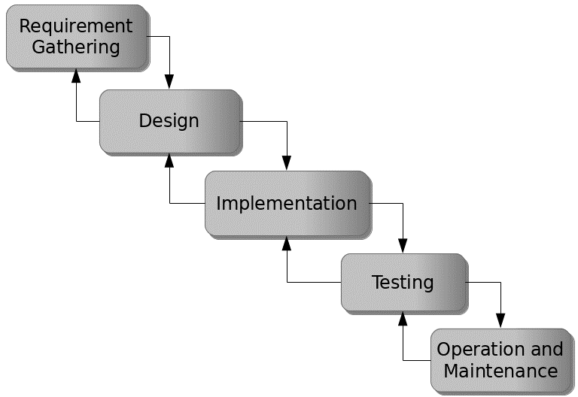

Figure 3.1: Waterfall model

## 3.5 Method of Data Collection

Both **primary** and **secondary** data sources were used in designing the system.

**Primary sources** included interviews with education consultants, surveys with potential scholarship applicants, and focus group discussions with international students.

**Secondary sources** consisted of academic literature, policy documents, and analysis of existing scholarship platforms and education grant websites to understand their features, limitations, and design frameworks.

## 3.6 System Design

The system design for the Online International Scholarship Portal involves developing a scalable architecture, defining user roles, setting up access privileges, and specifying the data flow across various modules. It includes the design of interfaces for students, administrators, and scholarship providers, ensuring intuitive navigation and secure interactions.

## 3.6.1 Algorithm Diagram

**Use case diagram**

A use case diagram shows the system and the various ways that they interact with the system.

**SCHOLARSHIP PORTAL SYSTEM**

Login

Applicant

Registration

Add New Scholarship

Admin

View Scholarship

Apply for Scholarship

Provider

Upload Documents

Approve/Reject

Logout

Figure 3.2: Use Case Diagram

**3.6.2 System Architecture**

Database MySQL

Apache Server

Scholarship Portal System



Figure 3.3: System Architecture

## 3.6.3 Database Tables/Queries Structures

The database is used to store all information that pertain the Scholarship records. Below are the database table for the new system.

**Table 1: Admin Table**

Top of Form

| **Name** | **Type** | **Extra** |
| --- | --- | --- |
| id Primary | int(11) | AUTO_INCREMENT |
| email Primary | int(11) |  |
| firstname | varchar(250) |  |
| lastname | varchar(250) |  |
| contact | varchar(250) |  |
| password | varchar(40) |  |
| status | int(5) |  |
| date | timestamp |  |

**Table 2: Student Table**

Top of Form

| **Name** | **Type** | **Extra** |
| --- | --- | --- |
| id Primary | int(11) | AUTO_INCREMENT |
| email | varchar(250) |  |
| Firstname | varchar(250) |  |
| Lastname | varchar(250) |  |
| Othername | varchar(250) |  |
| Photo | varchar(250) |  |
| password | varchar(250) |  |
| gender | varchar(250) |  |
| Date of birth | date |  |
| Place of birth | varchar(250) |  |
| Address | varchar(250) |  |
| City | varchar(250) |  |
| Contact number | varchar(250) |  |
| Course | varchar(250) |  |
| Nationality | varchar(250) |  |
| Date | timestamp |  |

**Table 3: Provider Table**

**Top of Form**

| **Name** | **Type** | **Extra** |
| --- | --- | --- |
| id Primary | int(11 | AUTO_INCREMENT |
| Name | varchar(50) |  |
| email Index | varchar(50) |  |
| password | varchar(50) |  |
| contact | bigint(11) |  |
| university/organization | varchar(50) |  |
| position |  |  |
| Date | timestamp |  |

**Table 4: Scholarships Table**

Top of Form

| **Name** | **Type** | **Extra** |
| --- | --- | --- |
| id Primary | int(11) | AUTO_INCREMENT |
| provider_id | int(11) |  |
| name | varchar(250) |  |
| location | varchar(250) |  |
| degree | varchar(250) |  |
| gender | varchar(250) |  |
| funding | varchar(250) |  |
| deadline | varchar(250) |  |
| description | varchar(250) |  |
| eligibility | varchar(250) |  |
| benefits | varchar(250) |  |
| apply | varchar(250) |  |
| approval_status | varchar(250) |  |
| status | varchar(250) |  |
| Date | timestamp |  |

Bottom of Form

**Table 5: Application Table**

Top of Form

| **Name** | **Type** | **Extra** |
| --- | --- | --- |
| id Primary | int(11) | AUTO_INCREMENT |
| student_id | int(11) |  |
| provider_id | int(11) |  |
| scholarship_id | int(11) |  |
| verifiedby | varchar(50) |  |
| status | varchar(50) |  |
| Date | timestamp |  |

## 3.6.4 Database Entity Relationship Diagram

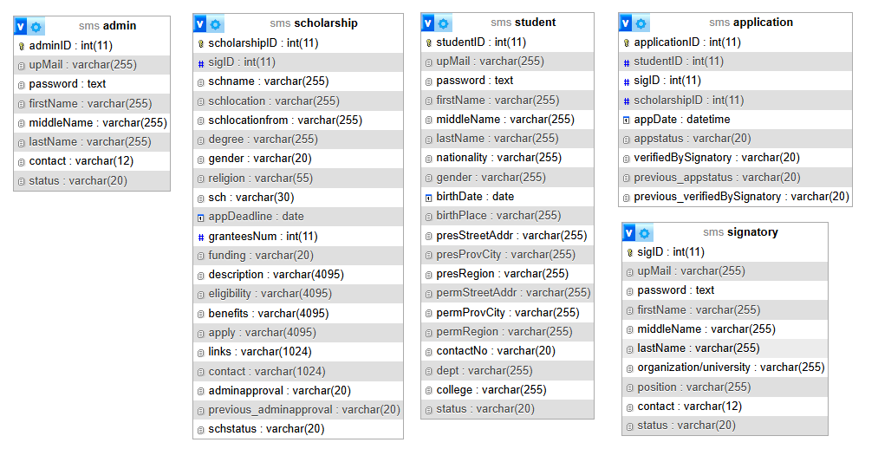

Figure 3.4: Database Entity Relationship Diagram

## 3.6.6 Input and Output Design

**REGISTRATION FORM**

Enter Email

Enter Password

**SUBMIT**

Confirm Password

Figure 3.5: Registration Form

**LOOGIN FORM**

Enter Email

Enter Password

**SUBMIT**

Figure 3.6: Login Form

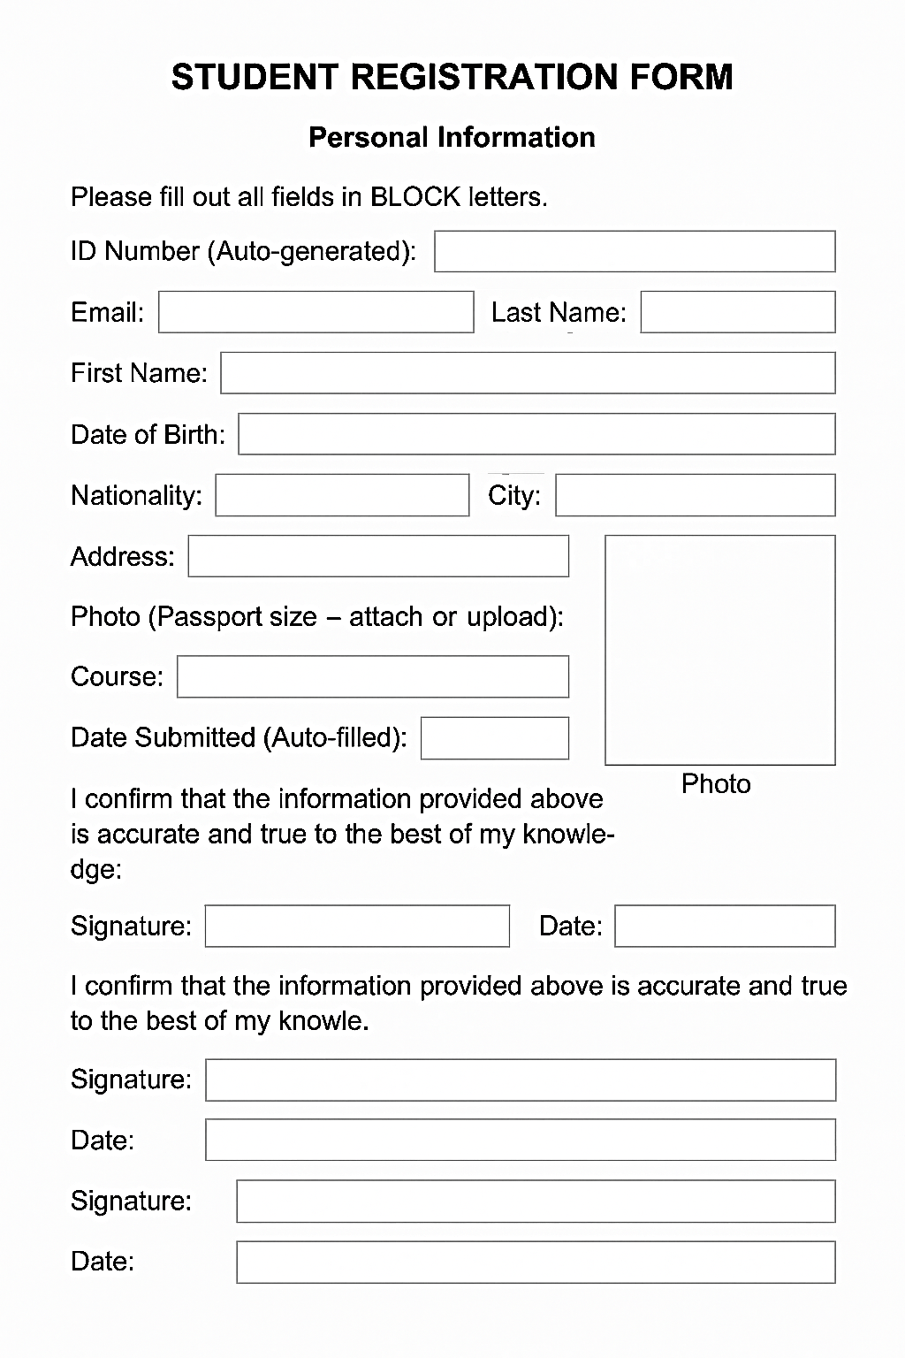

Figure 3.7: Student Registration form

| Name | DeadLine | Action | | | | |
| --- | --- | --- | --- | --- | --- | --- |
| Chevening Scholarships (UK) | 2025-06-16 | Top of Form  View  Bottom of Form | Top of Form  Approve  Bottom of Form | Top of Form  Reject  Bottom of Form | Top of Form  Block  Bottom of Form | Top of Form  Unblock  Bottom of Form |
| DAAD Scholarships (Germany) | 2025-08-22 | Top of Form  View  Bottom of Form | Top of Form  Approve  Bottom of Form | Top of Form  Reject  Bottom of Form | Top of Form  Block  Bottom of Form | Top of Form  Unblock  Bottom of Form |
| Erasmus Mundus Joint Master Degrees (EU) | 2025-07-23 | Top of Form  View  Bottom of Form | Top of Form  Approve  Bottom of Form | Top of Form  Reject  Bottom of Form | Top of Form  Block  Bottom of Form | Top of Form  Unblock  Bottom of Form |
| Fulbright Foreign Student Program (USA) | 2025-10-23 | Top of Form  View  Bottom of Form | Top of Form  Approve  Bottom of Form | Top of Form  Reject  Bottom of Form | Top of Form  Block  Bottom of Form | Top of Form  Unblock  Bottom of Form |

Figure 3.8: Available Scholarships

### ****Applications of Accepted Students****

| **Application Number[ID]** | **Applicant ID** | **Scholarship ID** | **Scholarship Name** | **Application Date** | **AppStatus** | **Provider Approval** |
| --- | --- | --- | --- | --- | --- | --- |
| 39 | 43 | 23 | Erasmus Mundus Joint Master Degrees (EU) | 2019-06-06 13:40:15 | Processing | Approved |

Figure 3.9: Accepted Students

## 3.7 System Requirement Specification

## 3.7.1 Hardware Requirements

The software to be design needs the following hardware for an effective operation of the newly designed system.

1. A system running on intel, P(R) duo core with higher processor
2. The-Random Access Memory (RAM) should be at least 512MB.
3. At least 20-GB hard disk.
4. A monitor.

## 3.7.2 Software Requirements

The software requirements include:

1. A window 7 or higher version of operating system.
2. XAMP or WAMP for Database
3. PHP
4. MySQL
5. Browser

## 3.7.3 Personnel Requirement

Any computer literate who has a technical knowhow of internet surfing can use the system because it is user friendly.

# CHAPTER FOUR

# RESULTS AND DISCUSSION

## 4.1 Introduction

The Online International Scholarship Portal is developed using PHP and MySQL to provide an efficient platform for managing scholarship applications, applicant records, and related operations. PHP is utilized for server-side scripting, enabling seamless insertion, updating, and retrieval of application and scholarship-related data from the database. MySQL serves as the backend database management system, securely storing all applicant details, scholarship information, and evaluation results. The system’s interface is designed with HTML and CSS to provide a structured, visually appealing, and user-friendly experience. Additionally, JavaScript is incorporated to enhance interactivity, perform real-time client-side validations, and dynamically update content without requiring full page reloads. This integration ensures an intuitive and responsive environment for both applicants and administrators.

## 4.2 Results

**4.2.1 Registration interface**

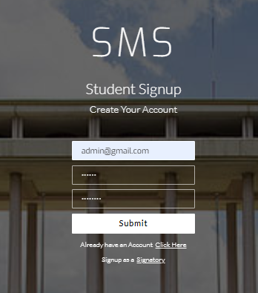

Figure 4.1: Registration interface

Figure 4.1 above shows where the student can register or create an account in the system using some basic information.

**4.2.2 Login Interface**

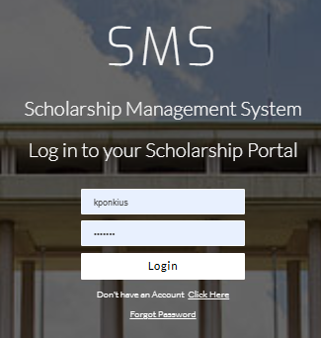

Figure 4.2: Login Interface

Figure 4.2 shows the login page of the system is where a user provides his or her login details (username and password) to gain access to the system.

**4.2.4 Email Verification interface**

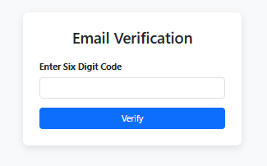

Figure 4.4: Email Verification interface

Figure 4.4 presents the verification interface view of a new user, where a 6-digit code will be entered to verify the account.

## 4.2.5 Available Scholarship interface



Figure 4.5: Available Scholarship interface

Figure 4.5 above shows the available scholarships currently on the system for students to select and apply for.

**4.2.6 Complete Profile Interface**

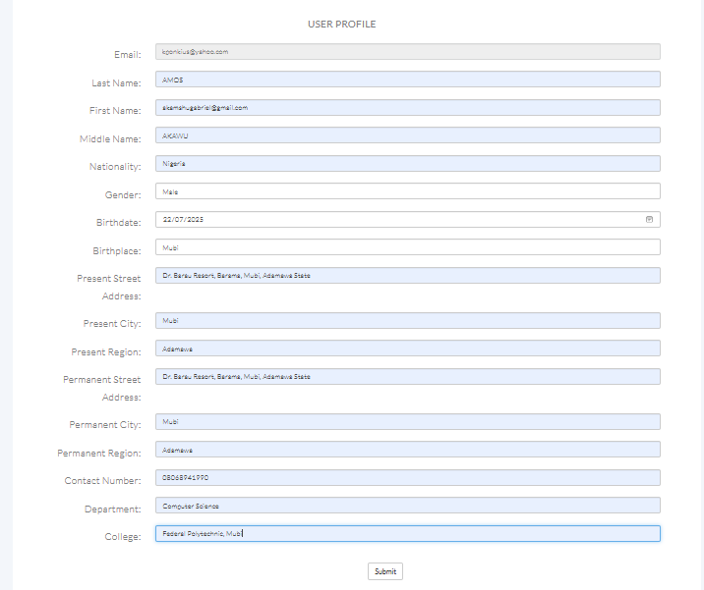

Figure 4.6: Complete Profile Interface

Figure 4.2 above represents the profile interface where the student will complete his or her profile before applying for any scholarship.

**4.2.7 Scholarship Status Interface**

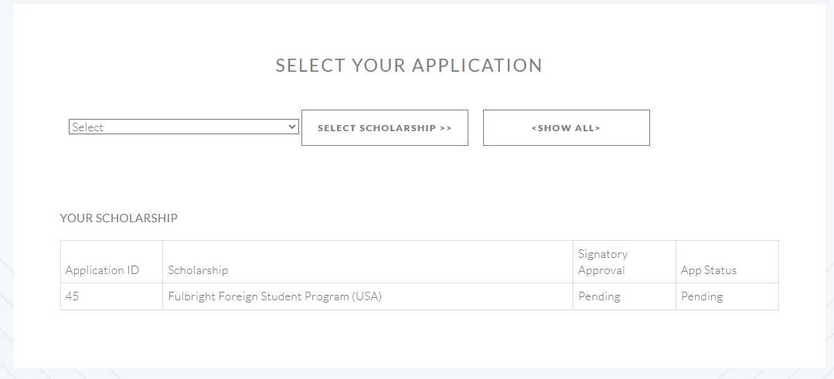

Figure 4.7: Scholarship Status Interface

Figure 4.7: shows the scholarship status where a student can track his or her scholarship application for approval.

## 4.3 Discussion

The Online International Scholarship Portal is designed with a set of well-structured interfaces that ensure ease of use, secure data handling, and efficient scholarship application management. Each interface serves a specific purpose in the user journey, from initial account creation to scholarship application tracking. The Registration Interface is the first interaction point for new users. It allows applicants to create accounts by providing essential details such as name, email address, and password. Proper form validations are implemented to ensure data accuracy and prevent errors during registration. This interface is optimized for both desktop and mobile devices, ensuring accessibility to a wider range of users globally.

The Login Interface provides a secure entry point for returning users. By entering valid login credentials, applicants can access their accounts and manage their scholarship applications. The interface uses encryption techniques to secure user credentials, preventing unauthorized access. It also incorporates “Forgot Password” functionality for account recovery. To maintain system integrity and prevent fake registrations, the Email Verification Interface prompts users to verify their email addresses. Upon successful registration, a verification link is sent to the provided email. The user must click the link to activate their account, ensuring that only legitimate applicants proceed to the application stage.

This interface displays a list of currently available scholarships, along with essential details such as eligibility criteria, application deadlines, and funding benefits. It incorporates filtering and search functionalities, enabling applicants to quickly identify scholarships relevant to their qualifications and interests. Before applying for scholarships, users are required to provide comprehensive personal, academic, and professional information through the Complete Profile Interface. This step ensures that the portal has adequate data to match applicants with the most suitable opportunities. The interface uses form validation to prevent incomplete submissions.

The Scholarship Status Interface enables applicants to monitor the progress of their applications in real time. Status updates such as “Submitted,” “Under Review,” “Shortlisted,” or “Rejected” are displayed. This feature improves transparency and reduces the need for applicants to make direct inquiries, streamlining the entire scholarship management process. Overall, these interfaces work together to provide a secure, intuitive, and efficient platform for both applicants and administrators. By integrating essential functionalities with user-friendly design, the portal ensures a smooth end-to-end experience for international scholarship seekers.

## 4.4 User manual

## 4.4.1 System Installation

The user manual is a clear and precise instruction on how a user can operate the propose system, without any stress and successful. The following steps required

1. Start or boot the computer form the hard disk
2. Double click on the folder that program is been stored in the desktop
3. Double click on the program and allow it to load gently
4. A security unit will display were the user will specify the user name and password the click OK.
5. A welcome menu will be displayed where the user has options to select which operation to be performed.
6. Click on exist on the welcome screen to exist from the program.

## 4.4.2 System Operational Guide

The following are the necessary steps to take in order to use the system efficiently and effectively.

1. Load the url of the system <https://localhost/scholarship/> the welcome page will be displayed.
2. Click on the **Proceed** button to proceed to the main system.
3. If you created an account, provide your login details by entering your username and password.
4. Depending on the login details provided you will be automatically directed to the dashboard.
5. The various task that you can perform on the portal will be displayed on the sidebar of the dashboard.

# CHAPTER FIVE

# SUMMARY, CONCLUSION AND RECOMMENDATIONS

## 5.1 Summary

This project focused on the design and implementation of an Online International Scholarship Portal using PHP, MySQL, HTML, CSS, and JavaScript. The portal was developed to streamline the scholarship application process, making it easier for applicants to find, apply for, and track international scholarship opportunities. The system comprises key interfaces such as the Registration Interface, Login Interface, Email Verification Interface, Available Scholarship Interface, Complete Profile Interface, and Scholarship Status Interface. These modules work collectively to ensure secure user registration, authenticated access, verification of applicants, display of available scholarships, detailed applicant profiling, and real-time tracking of application statuses. By integrating client-side interactivity with JavaScript and a robust backend using PHP and MySQL, the portal ensures data security, user-friendliness, and efficiency in managing scholarship applications. The project addresses major challenges in the manual scholarship process, such as lack of accessibility, delays in processing, and limited transparency.

## 5.2 Conclusion

The development of the Online International Scholarship Portal demonstrates the effectiveness of a web-based approach in managing scholarship applications and related processes. The portal provides an accessible, transparent, and efficient platform for both applicants and administrators.

Through secure authentication, real-time status updates, and comprehensive applicant profiling, the system improves user experience and enhances trust in the scholarship selection process. The integration of an email verification system further strengthens account security, ensuring that only genuine applicants can apply.

Overall, the project fulfills its aim of simplifying and automating the scholarship application process, making opportunities more accessible to applicants globally while reducing the administrative workload.

## 5.3 Recommendations

Based on the successful implementation of the system, the following recommendations are suggested:

1. Implement an intelligent algorithm to automatically match applicants to scholarships based on their profiles and qualifications.
2. Create an Android and iOS version of the portal to improve accessibility for applicants on mobile devices.
3. Include multiple language options to cater to applicants from different linguistic backgrounds.
4. Enable secure uploading and verification of supporting documents such as transcripts, recommendation letters, and identification cards.
5. Implement an automated email or SMS alert system to inform applicants of new scholarships and updates on their applications.
6. Link the portal to reputable global scholarship databases to expand the opportunities available to applicants.

# REFERENCES

Abubakar, I., & Bello, M. (2023). Assessing user experience in Nigerian scholarship portals: A usability study. *International Journal of Information Systems and Technology*, 15(2), 45–59.

Adebayo, M., & Musa, H. (2023). Transparency and administrative efficiency in scholarship management systems. *Journal of Higher Education Policy and Management*, 45(1), 67–82.

Adekunle, O., & Mohammed, R. (2021). Addressing misinformation in scholarship applications through centralized platforms. *International Journal of Educational Technology*, 9(3), 45–57.

Adepoju, A., & Adebayo, K. (2021). Development and usability of online scholarship portals in Nigeria. *African Journal of Information Systems*, 13(2), 101–115.

Afolayan, T., & Liu, Y. (2022). Scholarship portals as tools for equitable access to education: A global perspective. *Journal of Educational Access and Inclusion*, 5(4), 23–39.

Ahmed, S., & Othman, M. (2020). Blockchain and AI integration in scholarship application systems: Opportunities and challenges. *International Journal of Digital Innovation*, 8(1), 14–28.

Cheng, L. (2023). The role of centralized portals in improving scholarship accessibility. *Journal of Educational Technology Research*, 16(2), 88–104.

Chukwu, P., & Uche, C. (2022). Usability evaluation of international scholarship portals. *African Journal of Information Systems*, 14(3), 210–225.

Elmasri, R., & Navathe, S. B. (2019). *Fundamentals of database systems* (7th ed.). Pearson.

Ghazal, A., Rasheed, A., & Khan, M. (2020). NoSQL database management in big data environments: Benefits and challenges. *International Journal of Data Science*, 5(1), 12–27.

Gyamfi, S., & Larbi, J. (2020). Barriers to adoption of online scholarship portals in Ghana. *African Journal of Educational Technology*, 6(1), 25–39.

Kumar, V., & Singh, A. (2019). Comparative study of global scholarship portals: Usability and inclusivity. *Journal of Information and Communication Technology in Education*, 7(3), 55–72.

Lee, H., & Park, J. (2023). Comparative study on global scholarship platforms: Challenges and best practices. *Journal of Comparative Education Systems*, 11(1), 33–50.

Motahari-Nezhad, H., Stephenson, B., & Singhal, S. (2021). Ensuring privacy and integrity in database management systems. *Journal of Information Security and Applications*, 63, 102–114. https://doi.org/10.1016/j.jisa.2021.102900

Mustapha, A., & Yusuf, M. (2021). Benchmarking African scholarship portals: Functionalities and limitations. *African Journal of Information and Communication*, 12(4), 88–104.

Nguyen, T., Pham, H., & Le, M. (2021). Agile and DevOps in modern web-based application development. *Journal of Software Engineering and Applications*, 14(7), 299–313.

Oladipo, F., & Salawu, R. (2022). AI-driven scholarship application management: Ethical considerations. *Journal of Artificial Intelligence Ethics*, 4(3), 56–72.

Olatunji, B., & Zhang, Y. (2022). Improving engagement features in scholarship portals. *Educational Technology & Society*, 25(2), 77–91.

Pressman, R. S., & Maxim, B. R. (2020). *Software engineering: A practitioner’s approach* (9th ed.). McGraw-Hill Education.

Ramakrishnan, R., & Gehrke, J. (2020). *Database management systems* (4th ed.). McGraw-Hill.

Rizvi, S., Akhtar, M., & Alam, M. (2021). Efficient data retrieval in DBMS: A review. *International Journal of Computer Applications*, 182(27), 14–22.

Shah, P., & Patel, R. (2023). Node.js in high-concurrency educational systems. *International Journal of Web Engineering*, 12(1), 59–74.

Shneiderman, B., Plaisant, C., Cohen, M., Jacobs, S., Elmqvist, N., & Diakopoulos, N. (2018). *Designing the user interface: Strategies for effective human-computer interaction* (6th ed.). Pearson.

Singh, R., & Chauhan, P. (2021). User interface design trends in educational scholarship portals. *Journal of Web Design and Development*, 9(2), 44–60.

Stallings, W. (2021). *Cryptography and network security: Principles and practice* (8th ed.). Pearson.

Tetteh, E., & Boateng, K. (2018). The state of online scholarship portals in West Africa: Challenges and opportunities. *West African Journal of Educational Technology*, 4(2), 15–30.

UNESCO. (2022). *Digital scholarship platforms for equitable access to education*. Paris: UNESCO Publishing.

United Nations. (2023). *Education for all in the digital era: Policy brief*. United Nations Educational, Scientific and Cultural Organization (UNESCO).

Wang, L., Chen, Y., & Li, X. (2022). Front-end frameworks in modern web application development: A comparative analysis. *International Journal of Web and Mobile Development*, 10(3), 101–118.

Wanjiku, M., & Njoroge, P. (2022). Institutional adoption of portal-based scholarship systems in Kenya. *Journal of African Higher Education*, 14(1), 60–75.

Yeboah, R., & Smith, T. (2021). The impact of the COVID-19 pandemic on global digital education. *Journal of Educational Change*, 22(4), 567–589.

Zhou, H., & Chen, J. (2023). Cloud deployment strategies for scalable educational portals. *Journal of Cloud Computing*, 12(7), 45–61.

Zhou, X., & Jin, Y. (2020). Technical architecture considerations for online scholarship platforms. *International Journal of Information Systems and Technology*, 18(2), 78–93.

# APPENDIX A

Registration interface



Login Interface



Email Verification interface



Available Scholarship interface



Complete Profile Interface



Scholarship Status Interface



# APPENDIX B

**PROGRAM CODE**

<?php

require "header.php";

?>

<header class="header">

    <div class="row">

        <div class="col-md-12 text-center">

   <a class="logo"><img src="img/logo1.png" alt="logo"></a>

   </div>

        <div class="col-md-12 text-center">

            <button type="button" onclick="window.location.href='reservation.php'" class="btn btn-outline-light btn-lg"><em>Make a Reservation Now!</em></button>

        </div>

    </div>

</header>

<section id="aboutus">

 <div class="container">

   <h3 class="text-center"><br><br>Chocolate & Moer</h3>

   <div class="row">

<!--carousel-->

     <div class="col-sm"><br><br>

        <div id="carouselExampleIndicators" class="carousel slide" data-ride="carousel">

         <ol class="carousel-indicators">

           <li data-target="#carouselExampleIndicators" data-slide-to="0" class="active"></li>

           <li data-target="#carouselExampleIndicators" data-slide-to="1"></li>

           <li data-target="#carouselExampleIndicators" data-slide-to="2"></li>

         </ol>

        <div class="carousel-inner">

           <div class="carousel-item active">

             <img class="d-block w-100" src="img/3.jpeg" alt="First slide">

           </div>

           <div class="carousel-item">

           <img class="d-block w-100" src="img/4.jpeg" alt="Second slide">

           </div>

           <div class="carousel-item">

           <img class="d-block w-100" src="img/5.jpeg" alt="Third slide">

           </div>

        </div>

  <?php

$msg = "";

if(isset($_POST['booknow'])){

    $days =0;

    $day = dateDiff($_SESSION['arrival'],$_SESSION['departure']);

   if($day <= 0){

      $totalprice = $_POST['ROOMPRICE'] *1;

      $days = 1;

    }else{

      $totalprice = $_POST['ROOMPRICE'] * $day;

      $days = $day;

    }

                           <figcaption class="img-title">

                                <h5>'.$result->ROOM . ' <br/> '.$result->ROOMDESC.'  <br/>

                                ' . $result->ACCOMODATION .' <br/>

                                '.$result->ACCOMDESC . '<br/>

                                Number of Person:' . $result->NUMPERSON .' <br/>

                                Price:'.$result->PRICE.'</h5>

                            </figcaption>

                    ';

              }

              }else{

                $btn =  '

                 <div class="form-group">

                        <div class="row">

                          <div class="col-xs-12 col-sm-12">

                            <input type="submit" class="button rooms_button" id="booknow" name="booknow" onclick="return validateBook();" value="Book Now!"/>

                           </div>

                        </div>

                      </div>';

                    $img_title = '

                           <figcaption class="img-title">

                                <h5>'.$result->ROOM . ' <br/> '.$result->ROOMDESC.'  <br/>

                                ' . $result->ACCOMODATION .' <br/>

                                '.$result->ACCOMDESC . '<br/>

                                Number of Person:' . $result->NUMPERSON .' <br/>

                                Price:'.$result->PRICE.'</h5>

                            </figcaption>

                    ';

              }

//

                ?>

                 <form method="POST" action="index.php?p=accomodation">

                 <input type="hidden" name="ROOMPRICE" value="<?php echo $result->PRICE ;?>">

                  <input type="hidden" name="ROOMID" value="<?php echo $result->ROOMID ;?>">

                      <div class="card">

                        <img class="card-img-top"  src="<?php echo WEB_ROOT .'admin/mod_room/'.$result->ROOMIMAGE; ?>" alt="Room image description">

                        <div class="card-body">

                          <div class="rooms_title"><h2><?php echo $result->ROOM ;?> <?php echo $result->ACCOMODATION ;?></h2></div>

                          <div class="rooms_text">

                            <p><?php echo $result->ROOMDESC ;?></p>

                          </div>

                          <div class="rooms_list">

                            <ul>

                              <li class="d-flex flex-row align-items-center justify-content-start">

                                <img src="images/check.png" alt="">

                                <span>Number of Person - <?php echo $result->NUMPERSON ;?></span>

                              </li>

                              <li class="d-flex flex-row align-items-center justify-content-start">

                                <img src="images/check.png" alt="">

                                <span>Remaining Rooms :<?php echo  $resNum ;?></span>

                              </li>

                            </ul>

                          </div>

                          <div class="rooms_price"><?php echo   $result->PRICE ;?>/<span>Night</span></div>

                           <?php echo $btn ; ?>

                        </div>

                      </div>

                  </form>

                <?php

                 }

                ?>

              </div>

          </div>

 </div>